Module 11.2

Assignment 11.2
Course: CSD402-340A Java for Programmers
Prepared By: Mirach Erkol
Date of Report: 3/15/2025

https://github.com/Mikey5007/CSD340.git

11.2 Assignment:
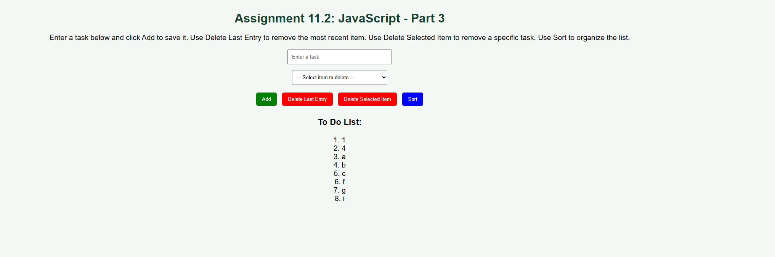

References:

https://github.com/Mikey5007/CSD340.git

